

MATHEMATICS
YEAR 8

Problem 3 – Angles in a Polygon
Semester 2 2014



Information for Students

Working time: 40 minutes
Marks available: 18 marks

Interior Angles In Polygons

You are going to investigate angles inside polygons and look at what the sum of the interior angles are when you add them up. We call the angles inside a polygon ‘Interior Angles’.
Follow the instructions below to fill in the table and then answer the questions at the bottom of the page.
INSTRUCTIONS
1. Measure all the interior angles inside the shapes on your worksheets using a protractor.
2. Add all the interior angles up for each shape and write the answer under each shape.
3. Work out the minimum number of triangles to check your answers for the sum of the interior angles using the ‘Minimum number of Triangles’ worksheet provided.
Round all your answers in the ‘sum of interior angles’ column to the nearest 10 degrees.
Shape name | Number of Sides | Min number of triangles | Sum of Interior Angles
Triangle | 3
Quadrilateral | 4
Pentagon | 5
 | 6
 | 7
 | 8
Nonagon | 9
 | 10
(10 marks)

Minimum number of triangles in a shape
Instructions – Rule a line from one vertex (corner) to all the other vertexes to figure out how many triangles are in each shape. Remember that each triangle has angles that add up to 180°.The first two have been done for you.

= 180° 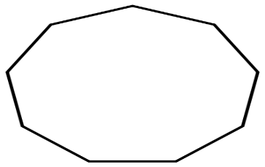

= 2 triangles = 2x180°
= 360°

Questions
1. Can you spot a pattern in how the sum of the interior angles increases as another side
is added to the shape? (1 mark)

2. Can you find a rule to explain how to get from the number of sides to the sum of the
interior angles? (2 mark)

3. Can you use your rule to work out what the sum of the interior angles would be for a
12 sided shape? (2 mark)

4. All the shapes in your investigation were regular (all sides and angles the same length).
Would the answers be the same for irregular polygons? (2 marks)
Work out the angles of these two irregular shapes to check if the answers would be the same.
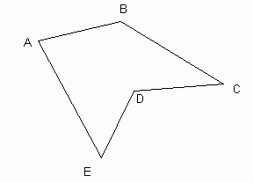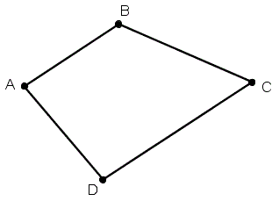
Sum of angles for 5 sided polygon?____ Sum of angles for a Quadrilateral?______
Would the answers be the same?______________________________________________________

5. For a polygon with n sides, write an expression to calculate the sum of the interior angles?
(1 mark)

End of Problem

